Cloud Browser Isolation Traffic Flow
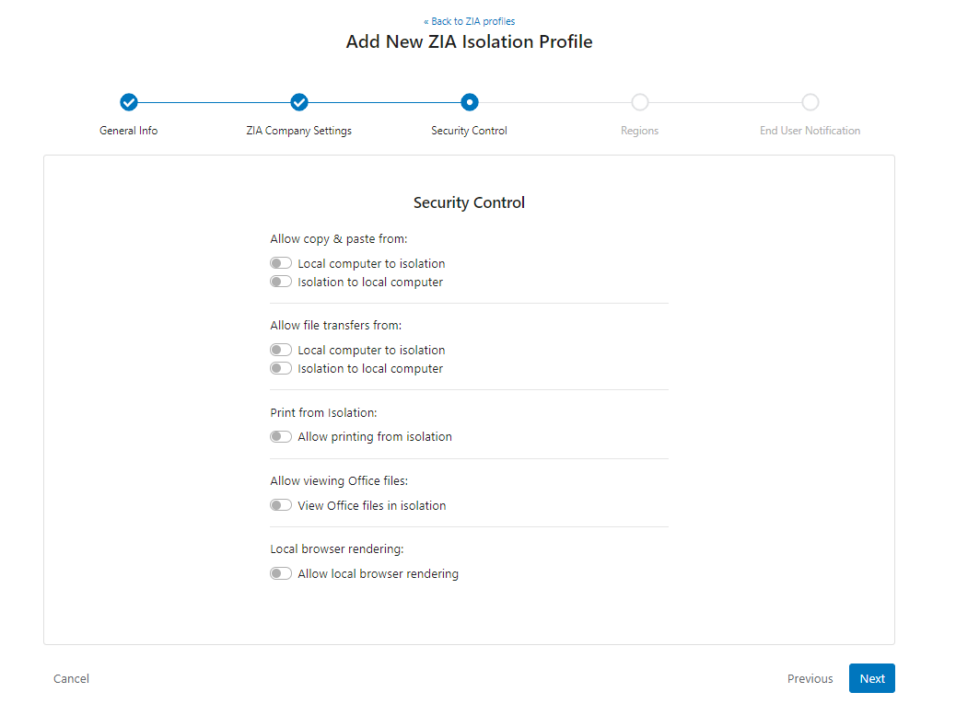

https://help.zscaler.com/zia/about-cloud-browser-isolation

